Okinawa Memory Initiative

Sprint 1 Planning (10/9 - 10/21) -- Rev 1 (10/9):

Product Owner: Kevin Tran

ScrumMaster: Jeff Liao

Team: Kevin Tran, Ankita Upadhyay, Tina Peng, Alfred George Francisco Milan III, Wellford Chan

Goal: To build a website for the Okinawa Memory Initiative.

1. History archive. Host 9000+ documents for easier access.
2. Search docs by name, tags...
3. Related events, announcements.
4. Membered user could able to share docs, pics, medias on website.

As an Okinawa Memory initiative (OMI) website user, I want to be able to share and view related documents, events, announcements, so that we could raise awareness to Okinawa's culture and history.

User Story 1:

As an Okinawa Memory initiative (OMI) website user, I want to be able to view related documents, events, announcements, so that we could raise awareness of Okinawa's culture and history.

Task PRIORITY: TASK DESC. (TIME IN HOURS) DIFFICULTY

Task Breakdown:

Task 1: Design UI (3) 2

Task 2: Homepage (2) 5  
Task 3: Header (1) 2

Task 4: Footer (1) 2

Task 5: About (1) 5

Task 6: Document Page (?) 5

Task 7: Archived Page (6) 5

Task 8: Login Page () 13

User Story 2:

As a user, I want to share my experiences in Okinawa’s culture.

Task Breakdown:

Task 1: User Login (3) 5

Task 2: Design user object (2) 5

Task 3: Design post object (2) 5

Task 4: API to post/get documents (2) 5

Task 5: Integrate API with FE (2) 5

Task 6: Connect to Database (5) 5

Task 7: API to list docs for search (5) 5

Task 8: API to post/get announcements (5) 5

Front End Pages: Home, login (Google Sign-in), about (and contact), document page, archived page, header, footer,

Must have: First Five tasks of user story 1

Should have: Task 1-8 of user story 1

Could have: Task 1-3 of user story 2

Won’t have: Task 1-8 of user story 2

Team Roles:

*Name: Main Role, {Secondary Role}*

Kevin Tran: Project Owner, {UI design, Frontend}

Jeff Liao: Scrum Master, {Frontend}

Tina Peng: Frontend {UI design, Backend}

Wellford Chan: Backend {Frontend}

Ankita Upadhyay: Backend {Frontend}

Alfred George Francisco Milan III: Full Stack

Initial Burnup Chart:

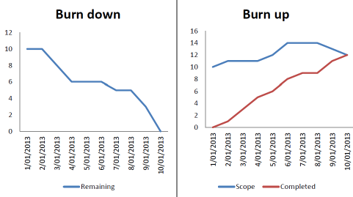

(http://www.clariostechnology.com/productivity/blog/burnupvsburndownchart)

Initial Scrum Board:

(Will make in github repo)

|  |  |  |  |
| --- | --- | --- | --- |
| Stories | ToDo | In Progress | Done |
| #1: View related documents, events, announcements related to Okinawa culture/history | * UI * Homepage * Header * Footer * About * Document Page * Archived Page * Login Page |  |  |
| #2: User should be able to share experiences in Okinawa culture (comment, share, contribute to the discussion forum) | * User login * Design user object * Designer post object * API to post/get documents * Integrate API with FE * Connect to database * API to list docs for search * API to post/get announcements |  |  |
|  |  |  |  |

Scrum Times: (SNE bottom floor) ~1hr long

Tuesday 3:30pm

Thursday 2:00pm

Sunday 7:00pm